

COMPANY RATING WEBSITE

DATABASE DESIGN

*Report #2*

|  |  |  |
| --- | --- | --- |
| **COMPANY RATING WEBSITE – *KẾ SINH NHAI TEAM*** | | |
| **Group Members** | Trần Quốc Hưng | SE02970 |
| Nguyễn Sơn Lâm | SE03090 |
| Nguyễn Việt Hùng | SE03293 |
| Nguyễn Nhật Quang | SE03122 |
| Trần Đăng | SE03039 |
| **Supervisor** | Bùi Đình Chiến | |
| **Project code** | CRW | |

**- Hanoi, 20/06/2016 -**

SIGNATURE PAGE

**AUTHORS**: Trần Đăng 08/20/2016

*Team Member*

Nguyễn Nhật Quang 08/20/2016

*Team Member*

**REVIEWER**: Trần Quốc Hưng 08/20/2016

*Team Member*

**APPROVAL**: Bùi Đình Chiến 03/06/2016

*Supervisor*

Record of change

*A – Added; M – Modified; D – Deleted

|  |  |  |  |  |  |  |
| --- | --- | --- | --- | --- | --- | --- |
| Effective Date | Changed Item | A,M,D* | Change Description | Reason for Change | Rev. Number | |
| 20/06/2016 | Database Design | A | First version | Create Database Design | | 1.0 |
|  |  |  |  |  | |  |
|  |  |  |  |  | |  |

# Table of Contents

SIGNATURE PAGE 2

Record of change 3

Table of Contents 4

1. INTRODUCTION 5

1.1. Purpose 5

1.2. Definitions and Acronyms 5

1.3. References 5

2. DATABASE 6

2.1. Entity-Relationship Diagram 6

2.1.1. Entity description 7

2.1.2. Relationship 7

3. COLLECTION DIAGRAM 8

*E01. RegisteredUser* 8

*E02. Company* 10

*E03. Review* 10

*E04. OverallReview* 11

*E05. SalaryAndBenefitReview* 11

*E06. Job* 11

*E07. Comment* 11

*E08. Notification* 12

*E09. Report* 12

# INTRODUCTION

## Purpose

CRW data design document describes the structure of the database and file structure of the system, including internal file structure as well as interface file structure.

## Definitions and Acronyms

1. Definitions and Acronyms

|  |  |  |
| --- | --- | --- |
| Acronym | Definition | Note |
| CRW | Company Rating Website | Project’s name |
| SRS | Software Requirements Specification |  |
| U | User | Including Guest, Member, Moderator and Administrator |
| M | Member |  |
| RU | Registered User | Including Member, Moderator and Administrator |
| AD | Administration | Including Moderator and Administrator |
| URL | Uniform Resource Locator | Website’s hyperlink |

## References

1. Referencial documents

|  |  |  |
| --- | --- | --- |
| Document | Title | Note |
| Software Requirement Specification | CRW_Software Requirements Specifications_v1.0_EN.docx |  |
| Architecture Design | CRW_Architecture-Design_v1.0_EN.docx |  |

# DATABASE



## Entity-Relationship Diagram

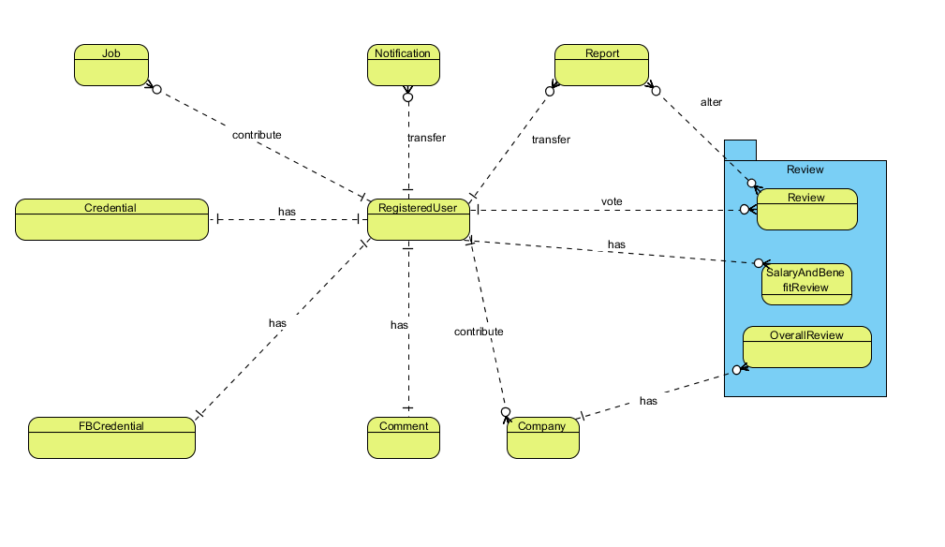

1. Entity-Relationship Diagram

### Entity description

1. List of entities and their description

|  |  |  |
| --- | --- | --- |
| No | Entity | Description |
|  | User | Those who have an account on CRW, be it members or administrators |
|  | Company | Basic information on the company for the reviewers to write a review upon |
|  | Review | A review with grading on a company |
|  | OverallReview | A review with grading on a company’s general basis |
|  | SalaryAndBenefitReview | A review with grading on a company’s salary and benefit basis |
|  | Job | Reviewed professions within the CRW |
|  | Comment | User’s commentary on a review |
|  | Notification | A to-be-sent-note triggered by a pre-determined pool upon a required action |
|  | Report | A report upon a review due to its rule breaking nature or more |

### Relationship

1. List of entities and their relationship within the system

|  |  |  |  |  |  |
| --- | --- | --- | --- | --- | --- |
| No | Relation | Properties | From | To | Description |
|  | TRANSFER | Send Date | RU | Notification | RU receive Notification from a triggering event |
|  | HAS | Create Date  Modify Date | RU | Review | RU interact with owned Review  AD interact with all Reviews |
|  | VOTE |  | RU | Review | RU give or remove an upvote from a Review |
|  | TRANSFER | Send Date | RU | Report | RU send a report  AD revise a report |
|  | ALTER |  | Report | Review | Report may or may not change a Review’s state depending on the AD |
|  | CONTRIBUTE |  | RU | Company | RU contribute to a Company’s info |
|  | HAS |  | Review | Company | Company receive Reviews from RU |
|  | CONTRIBUTE |  | RU | Job | RU contribute to Job’s name |
|  | HAS |  | RU | Credential | Account credentials for privacy |
|  | Has |  | RU | FBCredential | FB registered Account credentials for privacy |
|  | HAS |  | RU | Comment | RU interact with owned Comment |

# COLLECTION DIAGRAM

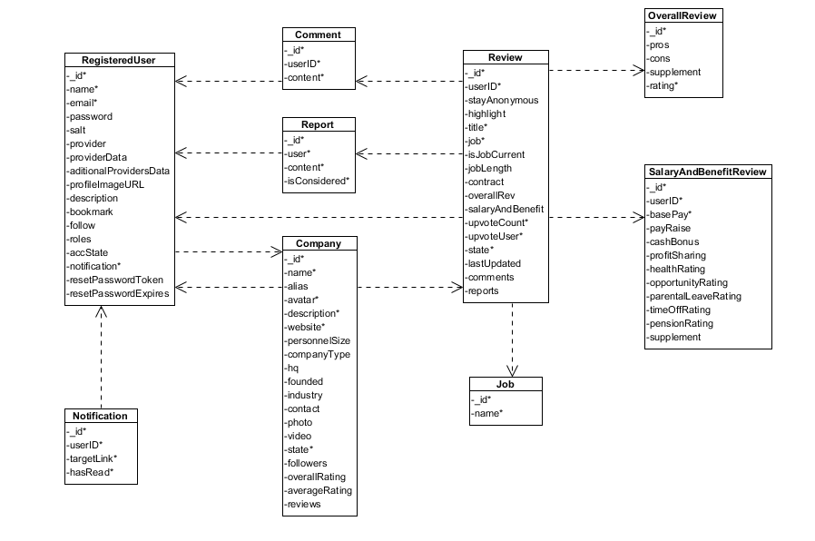

1. Collection Diagram
2. *User*
3. List of User properties

|  |  |  |  |  |
| --- | --- | --- | --- | --- |
| No | Name | Type | Required | Description |
|  | _id | ObjectID | Y | An identifier for accounts |
|  | name | String | Y | Displayed name |
|  | email | String | Y | Account’s email |
|  | password | String | N | Password if account is registered with an email |
|  | salt | String | N | Support password encryptions |
|  | provider | String | N | 3rd party ID for login |
|  | providerData | String | N | Required data from 3rd party |
|  | additionalProvidersData | String | N | Gathered data from 3rd party |
|  | profileImageURL | String | N | Account’s avatar |
|  | description | String | N | Account’s personal info |
|  | bookmark | Array | N | Bookmarked reviews’ identifier |
|  | follow | Array | N | Followed companies’ identifier |
|  | roles | String | Y | Account type (Member, Administrator) |
|  | accState | String | Y | Account state (Active, Banned) |
|  | notification | Array | Y | Notification. Has subcollection *Notification* |
|  | resetPasswordToken | String | N | Token used in password reset |
|  | resetPasswordExpires | Date | N | Token’s expire date |

1. *Company*
2. List of Company properties

|  |  |  |  |  |
| --- | --- | --- | --- | --- |
| No | Name | Type | Required | Description |
|  | _id | ObjectID | Y | An identifier for companies |
|  | name | String | Y | Company’s name |
|  | alias | Array | N | Company’s aliases |
|  | avatar | String | Y | Company’s avatar |
|  | description | String | Y | Company’s detailed info |
|  | website | String | Y | Company’s website |
|  | personnelSize | String | N | Company’s personnel size |
|  | companyType | String | N | Company’s type |
|  | hq | String | N | Company’s headquarter |
|  | founded | Date | N | Company’s founded date |
|  | industry | String | N | Company’s industrial focus |
|  | contact | String | N | Company’s contact |
|  | photo | Array | N | Company’s photoes |
|  | video | Array | N | Company’s video |
|  | state | String | Y | Company’s current state (Active, Locked) |
|  | followers | Array | N | Company’s follower pool |
|  | overallRating | Number | N | Company’s overall rating |
|  | averageRating | Number | N | Company’s average rating |
|  | reviews | Array | N | Company’s reviews pool |

1. *Review*
2. List of General Review properties

|  |  |  |  |  |
| --- | --- | --- | --- | --- |
| No | Name | Type | Required | Description |
|  | _id | ObjectID | Y | An identifier for reviews |
|  | userID | ObjectID | Y | An identifier for reviewers |
|  | stayAnonymous | Boolean | N | Anonimity of the reviewer |
|  | highlight | Boolean | N | State of reviews’ highlight |
|  | title | String | Y | Review’s title |
|  | job | Array | Y | Reviewer’s profession |
|  | isJobCurrent | String | N | Reviewer’s current state of profession |
|  | jobLength | String | N | Reviewer’s time soent as stated profession |
|  | contract | String | N | Reviewer’s type of contract |
|  | overallRev |  | N | Has subcollection *OverallReview* |
|  | salaryAndBenefit |  | N | Has subcollection *SalaryAndBenefitReview* |
|  | upvoteCount | Number | Y | Review’s amount of upvote |
|  | upvoteUser | Array | Y | Review’s upvoter pool |
|  | state | String | Y | Review’s state (Approved, Rejected, Pending) |
|  | lastUpdated | Date | N | Review’s last updated date |
|  | comments | Array | N | Has subcollection *Comment* |
|  | reports | Array | N | Has subcollection *Report* |

1. *OverallReview*
2. List of Overall Review properties

|  |  |  |  |  |
| --- | --- | --- | --- | --- |
| No | Name | Type | Required | Description |
|  | _id | ObjectID | Y | An identifier for reviews |
|  | pros | String | N | Review’s pros regarding the company |
|  | cons | String | N | Review’s cons regarding the company |
|  | supplement | String | N | Additional information regarding the company |
|  | rating | Number | Y | Review’s grading of the company |

1. *SalaryAndBenefitReview*
2. List of Salary and Benefit Review properties

|  |  |  |  |  |
| --- | --- | --- | --- | --- |
| No | Name | Type | Required | Description |
|  | _id | ObjectID | Y | An identifier for reviews |
|  | userID | ObjectID | Y | An identifier for reviewers |
|  | basePay | Number | Y | Reviewer’s base payment |
|  | payRaise | Number | N | Reviewer’s adjusted payment raise |
|  | cashBonus | Number | N | Reviewer’s bonus in cash |
|  | profitSharing | Number | N | Reviewer’s share in profit |
|  | healthRating | Number | N | Reviewer’s grading on healthcare policies |
|  | opportunity Rating | Number | N | Reviewer’s grading on promotion opportunity |
|  | parentalLeaveRating | Number | N | Reviewer’s grading on parental leave policies |
|  | timeOffRating | Number | N | Reviewer’s grading on paid leave policies |
|  | pensionRating | Number | N | Reviewer’s grading on pension policies |
|  | supplement | String | N | Additional information regarding the company |

1. *Job*
2. List of Job properties

|  |  |  |  |  |
| --- | --- | --- | --- | --- |
| No | Name | Type | Required | Description |
| 1. 1 | _id | ObjectID | Y | An identifier for professions |
|  | name | String | Y | Profession’s name |

1. *Comment*
2. List of Comment properties

|  |  |  |  |  |
| --- | --- | --- | --- | --- |
| No | Name | Type | Required | Description |
|  | _id | ObjectID | Y | An identifier for comments |
|  | userID | ObjectID | Y | Comment’s writer |
|  | content | String | Y | Comment’s content |

1. *Notification*
2. List of Notification properties

|  |  |  |  |  |
| --- | --- | --- | --- | --- |
| No | Name | Type | Required | Description |
|  | _id | ObjectID | Y | An identifier for notifications |
|  | message | String | Y | Notification’s content |
|  | targetLink | String | Y | Notification’s hyperlink |
|  | hasRead | Boolean | Y | Notification’s state (Read, Not Read) |

1. *Report*
2. List of Report properties

|  |  |  |  |  |
| --- | --- | --- | --- | --- |
| No | Name | Type | Required | Description |
|  | _id | ObjectID | Y | An identifier for reports |
|  | user | ObjectID | Y | An identifier for reporters |
|  | content | String | Y | Report’s content |
|  | isConsidered | String | Y | Report’s state (Approved, Ignored) |